- Introduction

  - Data Analytics

Data Analytics is the process of inspecting cleaning transforming and modelling data with the goal of discovering Useful information informing Conclusion and support in decision-making data analysis has multiple packed approaches and compass in diverse techniques and under of names and is used in different diseases Science and social science domain in today's business world art and display the role in making decisions more scientific and helping business operate more effectively

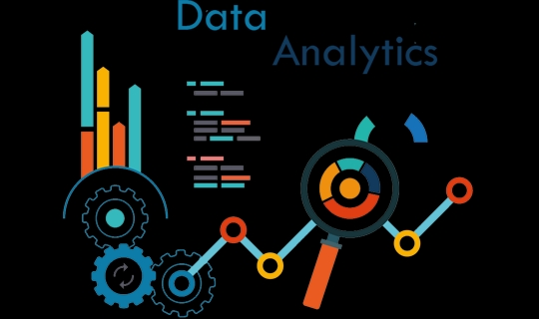

Figure 1: Insert your report image

  - Descriptive Analytics

descriptive analytics is the interpretation of storical data to better understand changes that have occurred in a business descriptive and desired describe the use of range of storing data draw comparison most commonly reported financial metrics are product of descriptive analytics for example year over their pricing changes month 12 month sales through the number of users of the total revenue per subscriber these measures all describe the what has a guard in a business during a set period
descriptive analytics is the process of passing storical data to better understand the changes that occurred in a business using a range of historical data and bench marketing decision makers of Elastic view of performance and trends on which the tube is business strategy descriptive and can help to identify the areas of strength and weakness in a organisation example of metrics used in descriptive and it includes year over year pricing changes month government sales growth the number of users or the total revenue person descriptive and is now being used in conjunction with the new owner dispatches Pitti when it when it exceeds in simplest form dispute and answer the question of what happened

Predictive anyltics
predictive analytics is an area of statistics in that is with access to information from that I needed in unpredictable behaviour patterns the enchantment of predictive analytics calculates statistical properties of future events online building plan that after the unknown event of interest in the future but can I can apply to any type of unknown whether it be in the past present or future for exam identify expect after a crime has been committed or credit card slots that it's occurs the core of the event capturing register between external variable bacterial variables from pass techniques as to team dependability on the level of data and explain the quality of dementiGenelia competitive antic used to mean predictive modelling scoring that are the predictive models and forecasting our people are increasingly using the term refer to related and disciplines such as table Modelling and decision Modelling and Optimisation these disciplines also involve bridges data analysis are widely used in the business for segmentation and isn't making but I have different purpose and the set is the techniques underline them underlying them very

Diagnostic analytics
Data plays an ever increasing role in every company using Diagnostic tools without to get the most out of it by translating your Complex data into visualisation and insights that everyone can take advantage of trade tool that you can use to uncover answers to all your data question in English and start the easy and help you get value out of your data by asking the right questions and making deep dive into the answer and this required and analytics platform that was child is well and customisable then again advances that are specific to your business and your particular challenges and opportunities

Figure 2: Insert Diagrams here

Figure 3: Testing Mode [15]

Prescriptive analytics
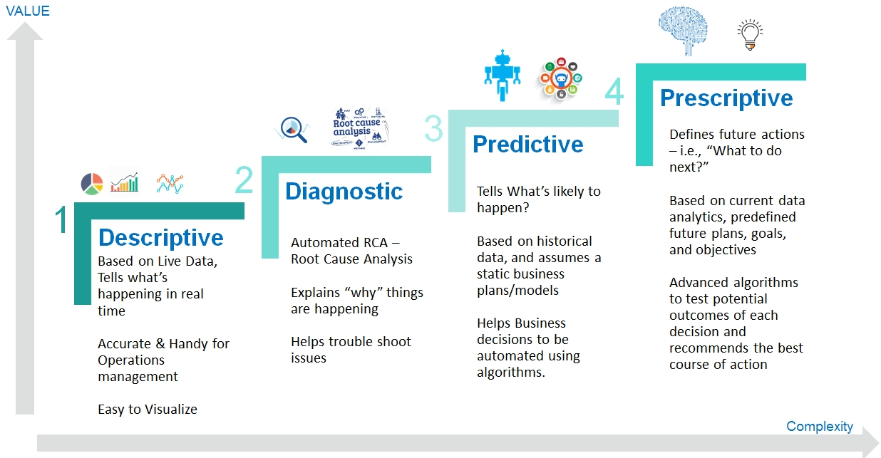
prescriptive and prescriptive and the type of Data Analytics the use of Technology help business make better decisions and through the analytics of row data it can be used to make this and any time Horizon from image data term

6. Summary and Future Work
Write your content here

References

